Speech and Language Therapy Services

What is the Curiosity Programme?
The Curiosity Programme was developed by Gina Davies. It is a fun-filled interactive approach which promotes curiosity and encourages exploration while designed to support children with their attention, language and social communication. This play-based intervention aims to meet the needs of your child by supporting their shared attention and functional communication skills.
The curiosity programme consists of four stages:
- Get Connected
- Signature Songs
- Creating Curiosity
- Playing Together

Stage 1: Get Connected
Getting connected is an Intensive Interaction approach to support adults in tuning into and developing your child’s social communication and interaction skills. The focus on this stage is to build relationships and communication through shared enjoyment.
We achieve this by:
- Imitating sounds, movements, and actions to show interest and create a shared connection.
- Modelling interactions and inviting children to respond in ways that feel meaningful and enjoyable for them.
- Using exaggeration, animation, and playfulness to capture attention and encourage engagement.
- Sharing interactions and experiences to build opportunities for connection, communication, and enjoyment.
- Following your child's lead, responding to their interests, preferences, and communication style.
- Creating positive, enjoyable interactions that will help develop confidence, attention, turn-taking and social awareness.

Stage 2: Signature Songs
The use of rhythm, intonation and short repetitive rhymes can make everyday activities more engaging, enjoyable and encourage participation. The rhymes and songs to support daily routines can help your child build a connection to activities in a fun way, e.g. brushing teeth, getting dressed, tidying up and lining up. Children can join in by humming, singing and doing the actions.
A few examples:
- To the tune of Row, Row, Row Your Boat:
Line, line, lining up, standing in a row,
Quietly, quietly, quietly, quietly, through the door we go.

- To the tune of Here We Go Round the Mulberry Bush:
This is the way we brush our teeth, brush our teeth, brush our teeth.
This is the way we brush our teeth, brush, brush, brush.

This is the way we tidy up, tidy up, tidy up.
This is the way we tidy up to put all the toys away.

Stage 3: Creating Curiosity
Creating curiosity provides opportunities for your child to develop curiosity and attend and explore a variety of containers with different sensory items. We recommend exploration of the curiosity containers for up to 3 minutes with an adult modelling excitement, building the tension by peeking inside the box and then exclaiming e.g. ooh!
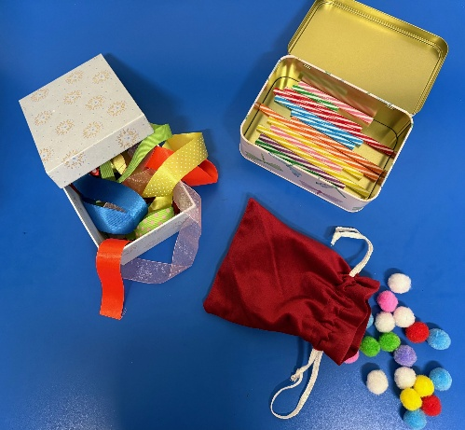
We achieve this by:
• A collection of assorted items, using the same items in different colours, size and type for e.g. pom poms, buttons, balls, feathers, straws, dried pasta.
- Avoid using containers with mixed objects as this can be visually confusing.
- Ensure you use containers that are visually appealing to children with a variety of textures and materials.
• Follow your child’s lead and let them explore the objects in their own way.
- Model several ways to explore curiosity items for e.g. pouring, sprinkling, sorting into groups/patterns.

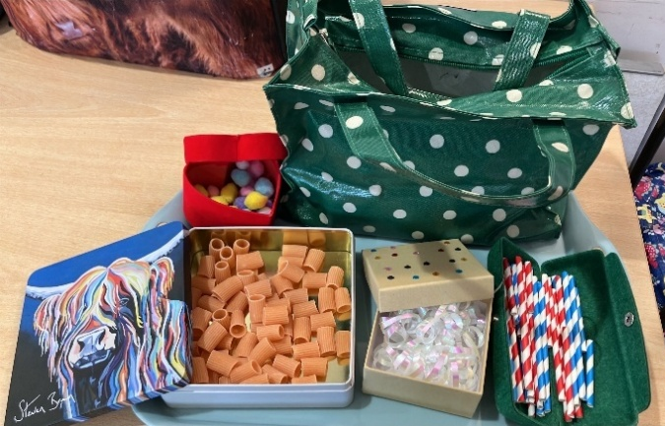

Stage 4: Playing Together
Playing together focuses on creating opportunities that are enjoyable and meaningful for your child to feel valued, connected and motivated to communicate with you. Engaging in activities in a natural and enjoyable way and, as adults, recognizing their interests, copying what they do and joining in with their play. This supports building connections, positive interactions and communication while continually supporting their development of early social and communication skills.

We encourage this by:
- Following your child's lead and responding to what captures their interest.
- Joining in with activities that your child is already enjoying.
- Copying your child's actions, sounds and play ideas to create a shared experience.
- Trying new activities and experiences together.
- Adding rhythm to words, sounds and actions to make interactions more engaging.
- Using songs and simple rhythms during play and everyday routines.
- Celebrating responses and contributions, no matter how small.
- Creating opportunities for turn-taking and shared enjoyment.

Activities to consider to encourage interaction:
Gone!
- Playing peek-a-boo.
- Hiding toys under objects such as boxes or blankets.
- Covering and uncovering objects while using specific words "gone!" and "there it is!"

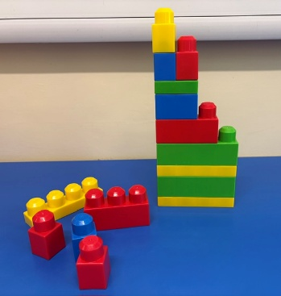
Building
- Building towers with different objects such as blocks and cups.
- Taking turns to add pieces.
- Excitement knocking the towers down and building a tower again.

Scribbling
- Providing large sheets of paper and a variety of coloured crayons.
- Following your child's ideas and celebrating their creations – for the love of scribbling!

Odd One Out
- Creating collections of similar objects with one random item for children to sort, match, group and find the random object.

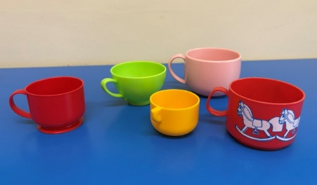

Giving
- Passing objects to each other.
- Rolling a ball to each other.

Unwrapping
- Loosely wrapping objects to encourage a child to reveal and discover the hidden object to build excitement for the item to be uncovered.

Adapted from The Curiosity Programme – Gina Davies and adapted from AI.

